CSIT 432

Fall 2022

Final Project Report

Mateen Olanrewaju

**Task 1:**

In the Final Project for my System Administrator class the first task which was asked, was to solve Routing which first I signed into my VM1 using the ssh command followed by the IP address of my VM1 and then I ping VM3 address and received this image which is a sign that my VM3 was ping from my VM1.

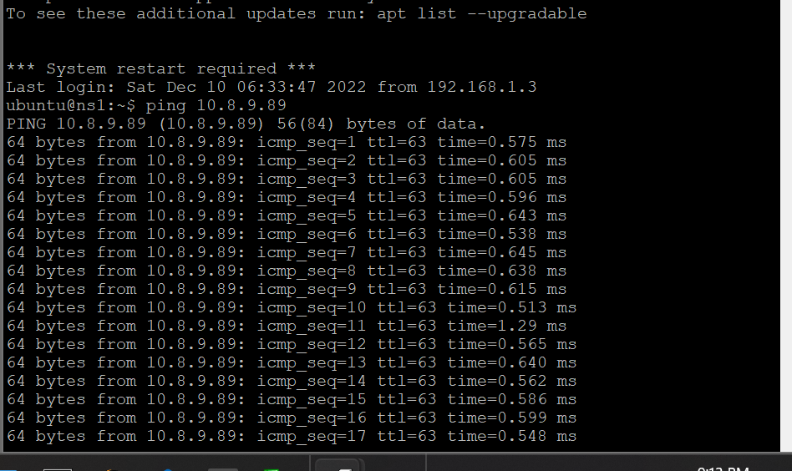

**Task 2:**

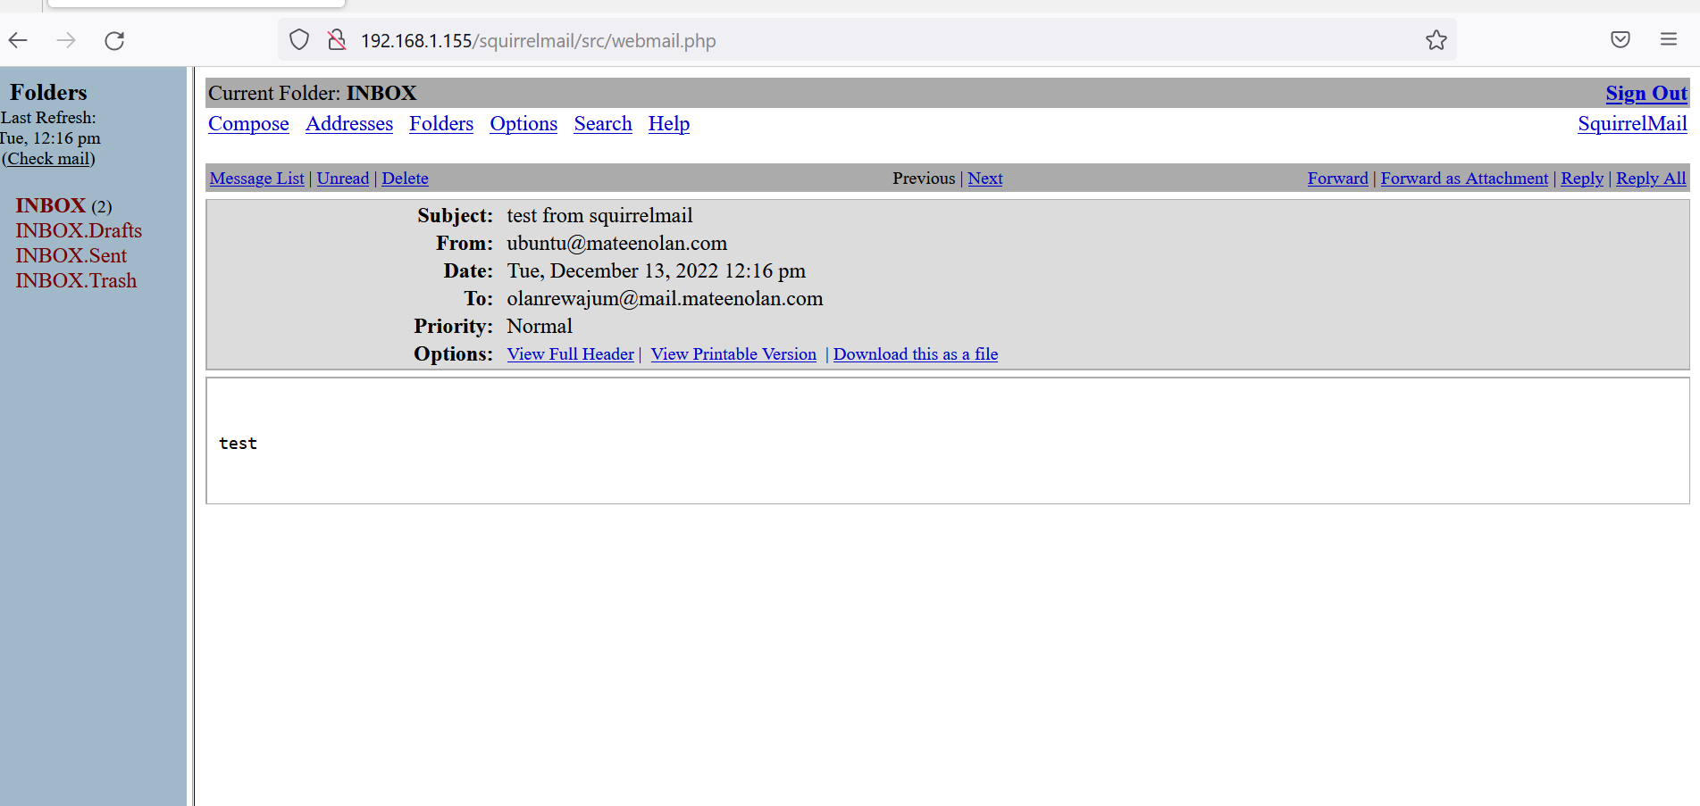

For Task 2 what I did was first I logged into my VM3 address on Putty and then I went on Firefox and log into my squirrel mail account using the ubuntu account and I sent it to my [olanrewajum@mail.mateenolan.com](mailto:olanrewajum@mail.mateenolan.com) which was one of the users I created on VM3. So, I checked my Squirrel mail inbox and noticed it did not send. So, I went on the cd/postfix command and made some changes. Then I resend the mail and it shows that the message was sent.

**Task 3:**

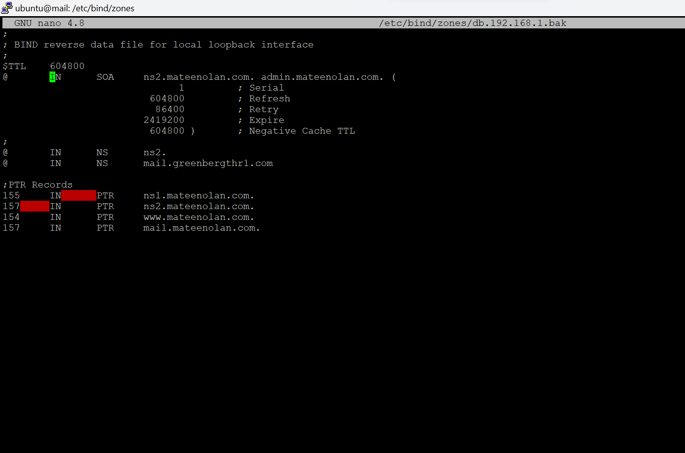

So first I logged into the Vm3 and added the mail.greenbergthr1.com into the sudo nano /etc/bind/zones/db.192.168.1.bak directory and saved it.

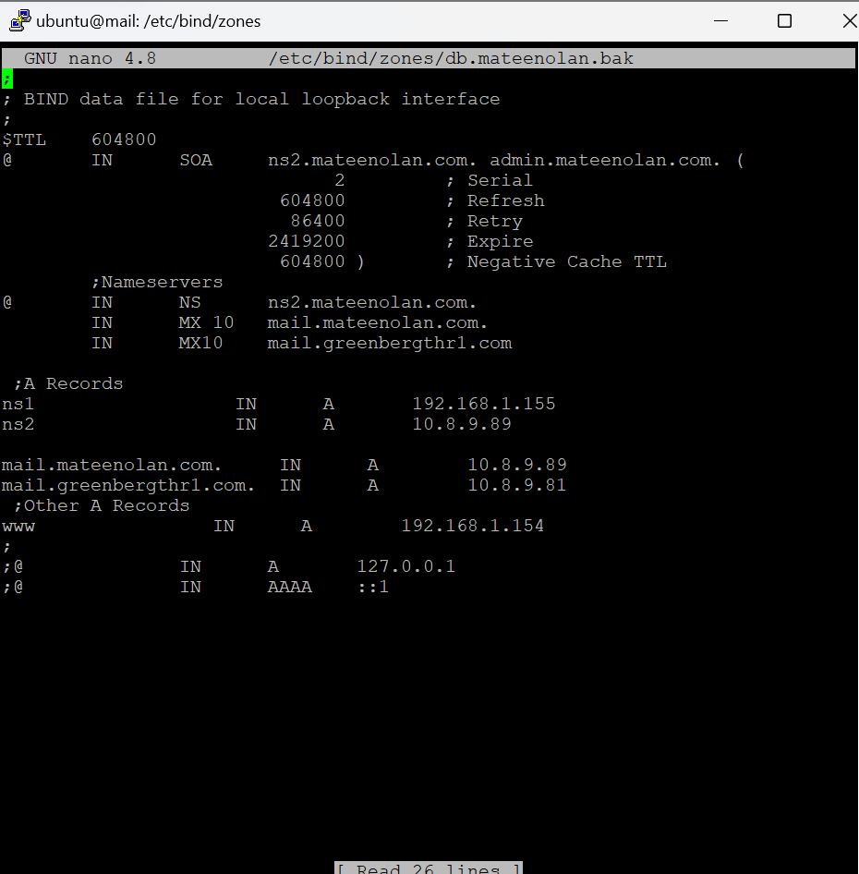

Then I went to sudo nano /etc/bind/zones/db.mateenolan.bak to make some changes which I added mail.greenbergthr1.com with the IP address which was 10.8.9.81 into the file directory and saved it.

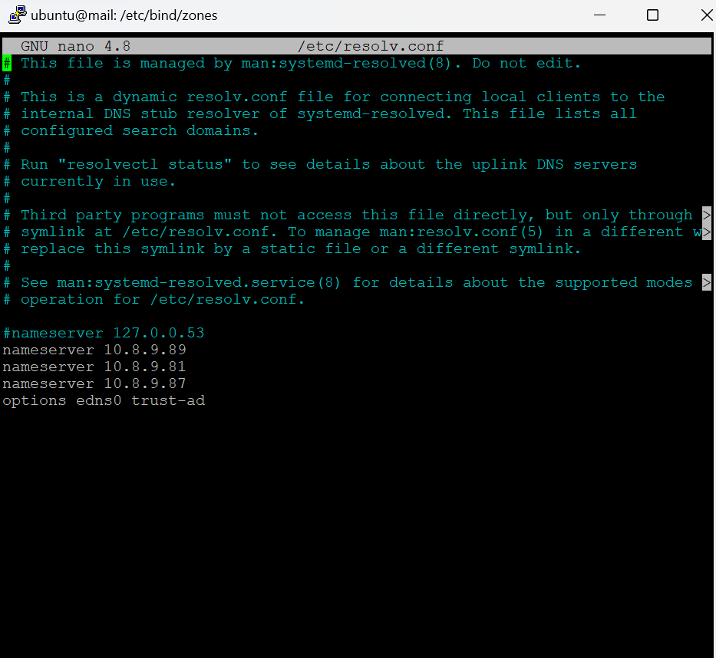

Then I went to the sudo nano /etc/resolv.conf file directory and added the nameserver with my Vm3 address. And next I added the 10.8.9.81 address with the nameserver which that is the address of where the mail is going. And the last address is someone else VM3 address in my class which is 10.8.9.87 and saved the file after.

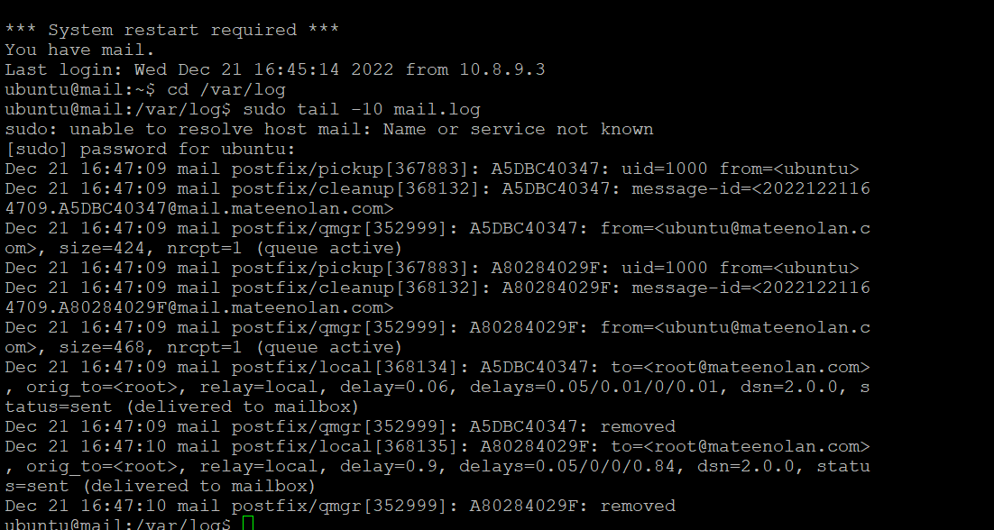

Then I checked the status of the mail that I sent using this command:

cd /var/log

sudo tail -10 mail.log which displays the date and time I sent the email to  [leberkc@mail.greenbergthr1.com](mailto:leberkc@mail.greenbergthr1.com) .

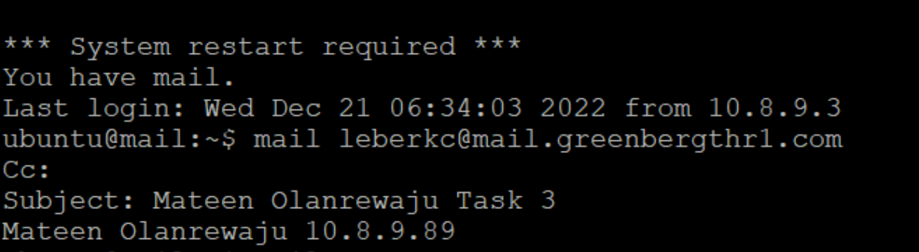

**Task 4:**

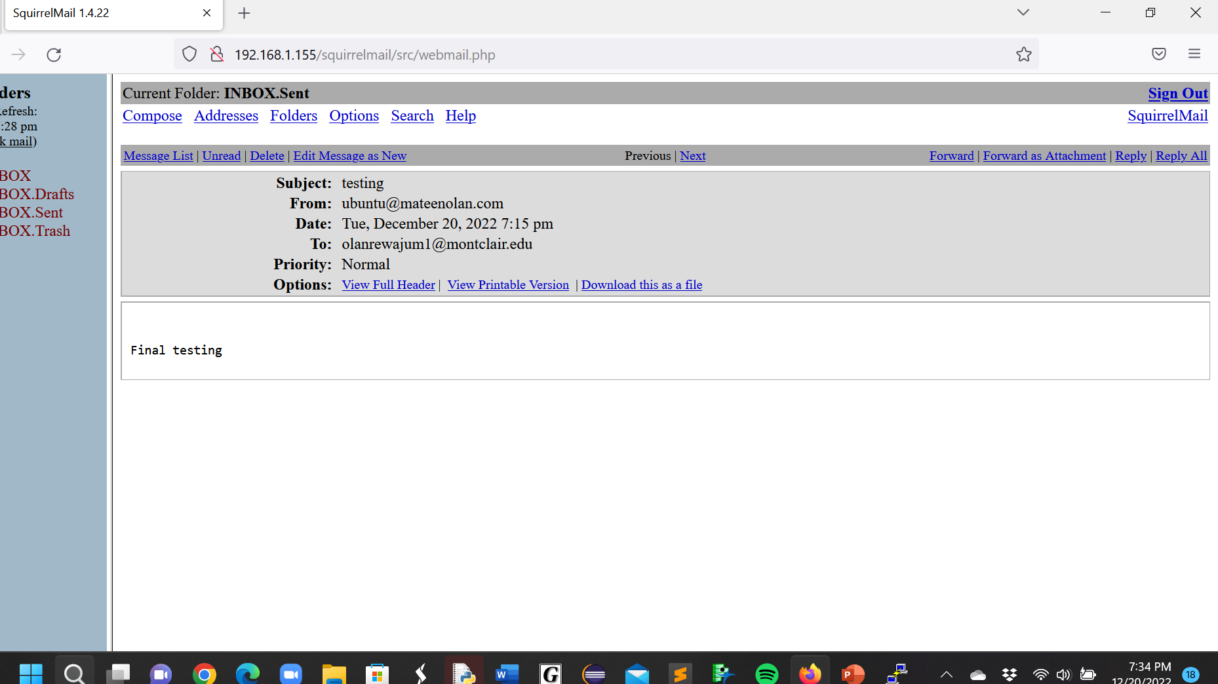

Before sending the external email what I did first was I logged into my VM1 which was 192.168.1.155 and then I went into Firefox and logged in as ubuntu user and then sent the email to my school email and then I received a notification in my school email that an email was sent from my ubuntu user which was the screenshot at the bottom. For this to work you must first sign into Putty with your VM1 address.

Then After I sent the email, I received this message in my school email address which is a confirmation that the email I sent went through my school Email Address.

